He Moved a Mountain:

The Life of Frank Calder and the Nisga’a Land Claim Accord

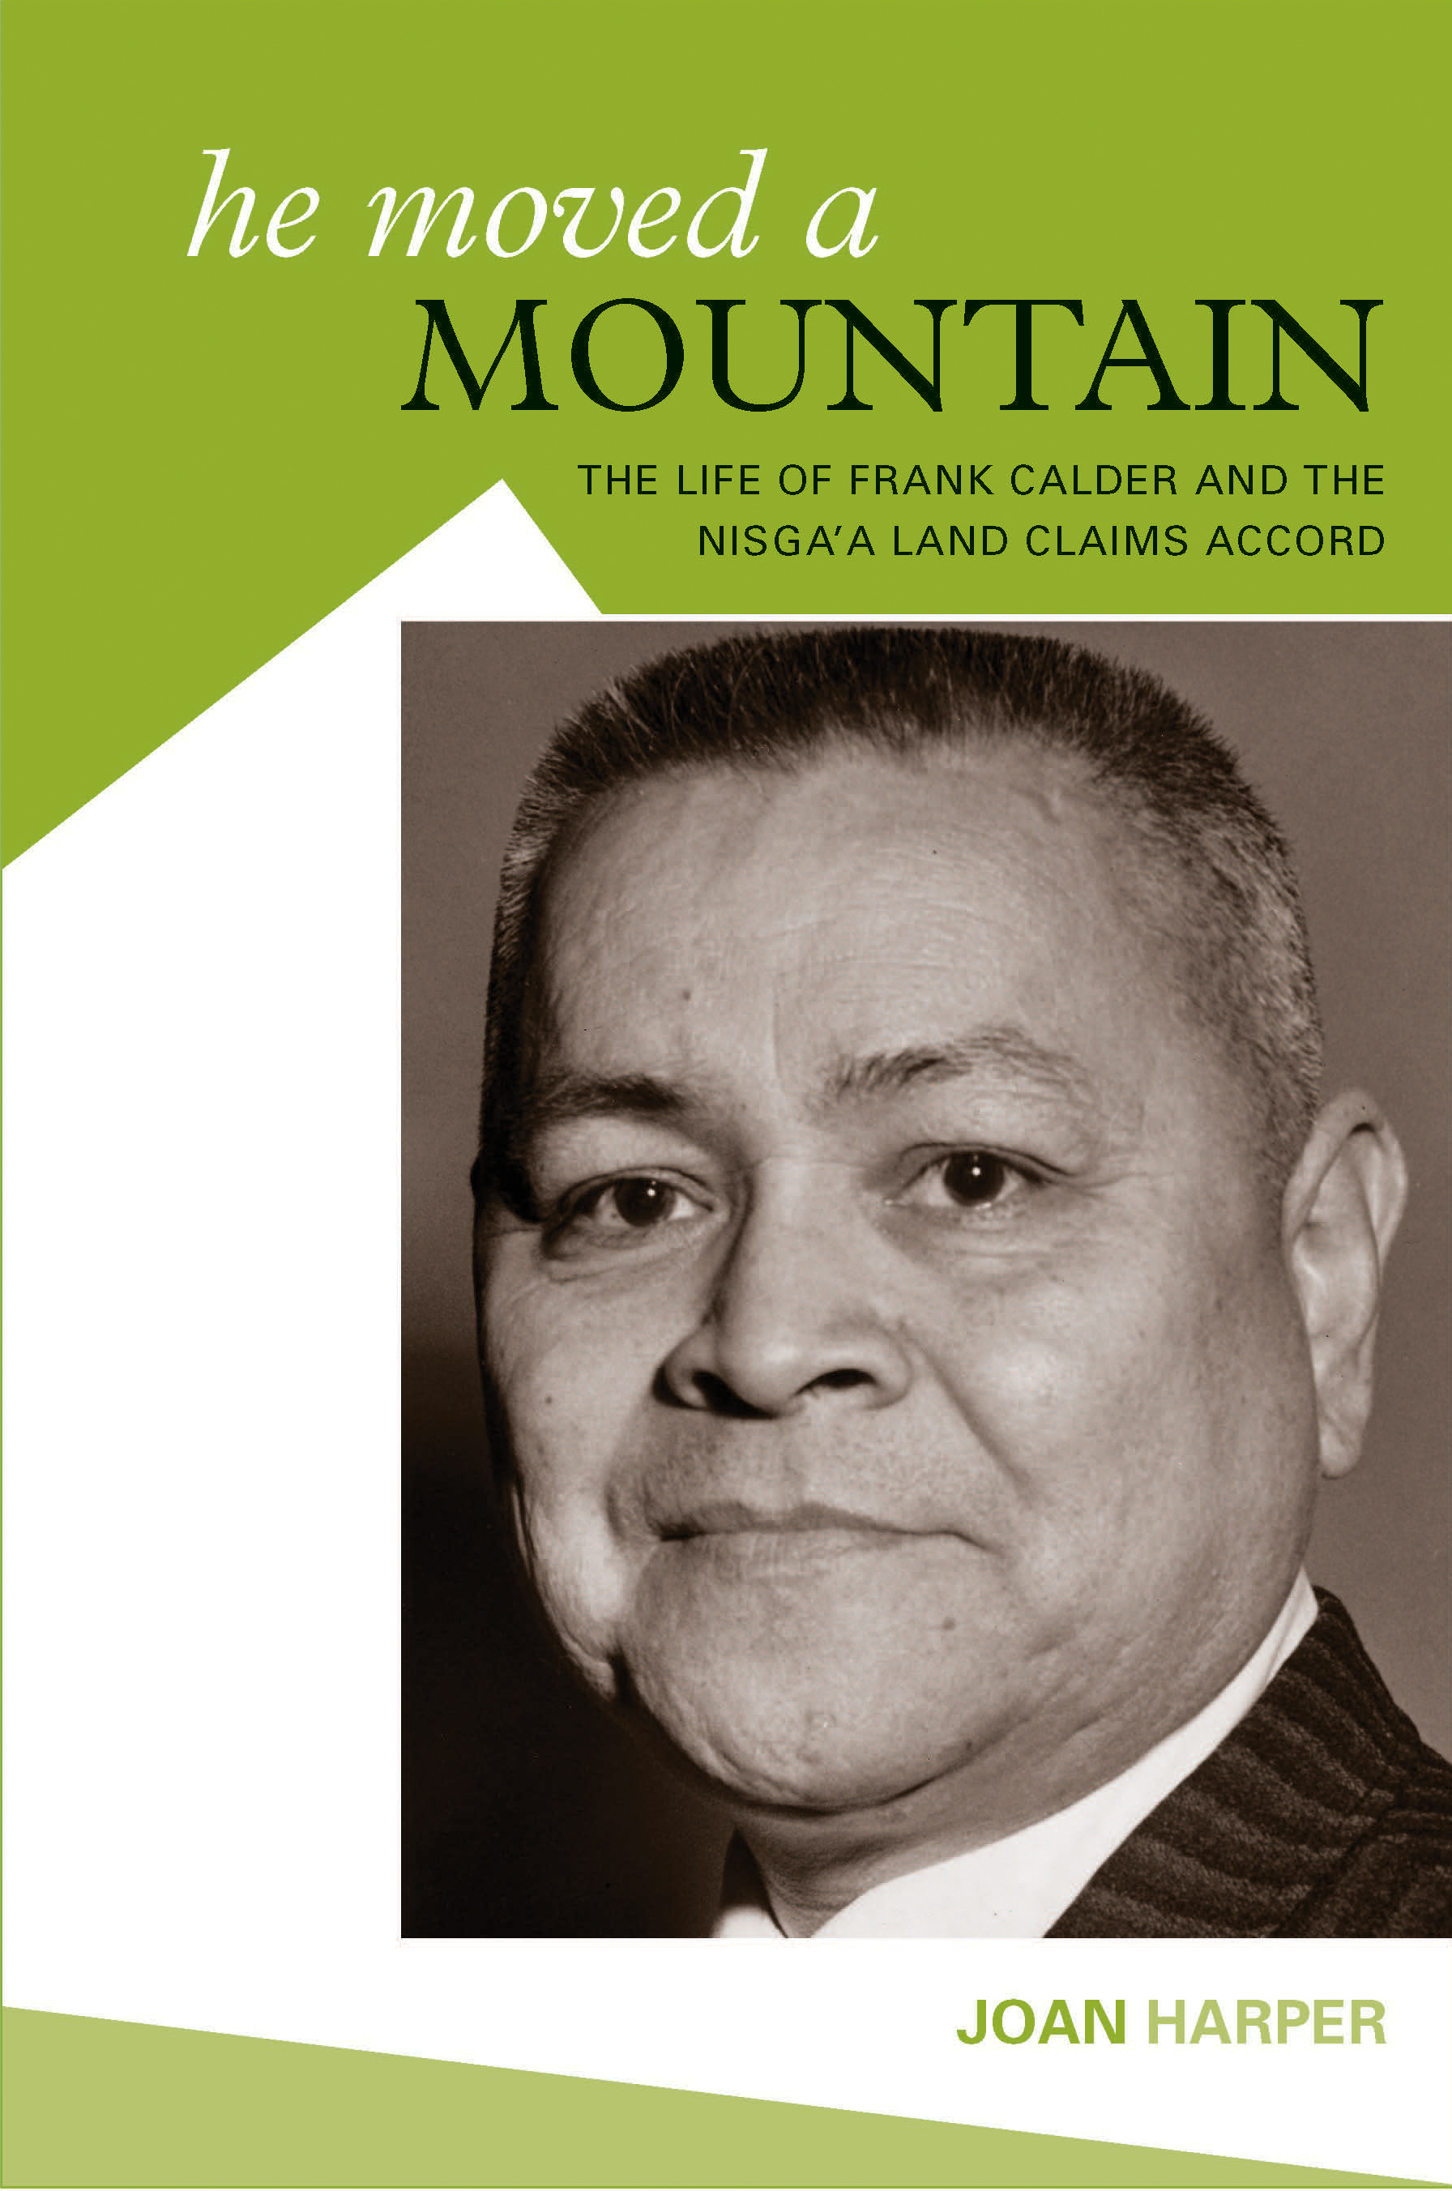

Discussion Questions

1. In your opinion, what were the main reasons the Nisga’a Nation was passionate about achieving legal title to their land?

2. Chief Clifford Azak was a Nisga’a chief after the Nisga’a Treaty was signed. He says, “We do not have land claims. We have land settlements. We have always owned the land.” Do you agree or disagree? Explain why or why not.

3. Frank was fortunate and had a good experience at Coqualeetza Residential School. It helped him go on to higher education. Do you think other First Nations students were sometimes helped by residential school as well as many that were mistreated?

4. Frank studied at the University of British Columbia and graduated as a minister for the Church of England. He remained faithful to his religion throughout his life. How do you think religion affected his future life and his political viewpoints?

5. On video Frank says, “In 1871, there was no provision made for First Nations Land Title when British Columbia joined the Confederation of Canada.” Discuss reasons why it was not included.

6. The Nisga’a Treaty was the first treaty negotiated in BC after Canada’s federal parliament in Ottawa made First Nations’ land title law. The treaty process took nine years and millions of dollars were spent. There are many other First Nations to settle with in BC. Do you think each treaty should be negotiated separately or do you think a standard settlement should be made with all nations?

7. Frank had given his party 24 years of service (the New Democratic Party) when he was fired from cabinet. It was over a drinking incident (he wasn’t driving), but he did not immediately inform his party leader, Dave Barrett. Do you think this was fair? Do you think any other political party would have treated him differently?

8. Many people believe that in elections it is better to vote for the best candidate rather than for the political party. They want someone who will stand up for what is right even when they consider their own party is wrong. Frank was one who did so and eventually paid the high price of being fired from cabinet. Do you think this is why most elected members of legislatures and parliament “tow the party line?” Is this a failing of our democratic system?

9. Today there are many First Nations young people attending universities. In your opinion, will they become leaders and influence change? How?

10. Since the Nisga’a Treaty, the Nisga’a have changed ownership of their lands to the fee simple system. It means that their people can own land, build houses and sell them or transfer them to anyone they wish. In other First Nations the land is still owned collectively by the nation and members can live on the land but only their First Nation can sell or transfer it. Do you think all First Nations should institute the fee simple system? It exists for all land in Canada outside First Nations land.

